### Configure & Launch the EC2 Instance

First of all you need to have an AWS account. If you don’t have one, you can create a new account on AWS ([https://aws.amazon.com](https://aws.amazon.com/)) and get one year computing, storage and serveral other services for free using the so called “Free Tier”.

1. Logon to the AWS Console and then select EC2 in services Section

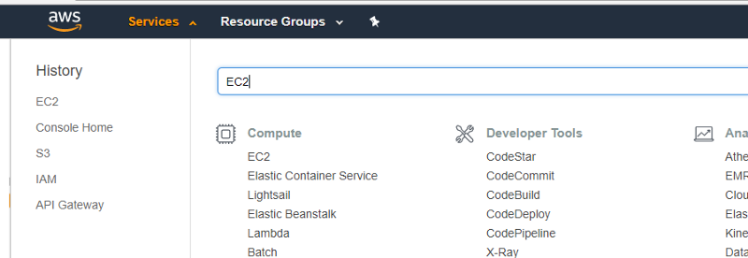

Select EC2

2. Select the preferred AWS regionand then launch a new instance

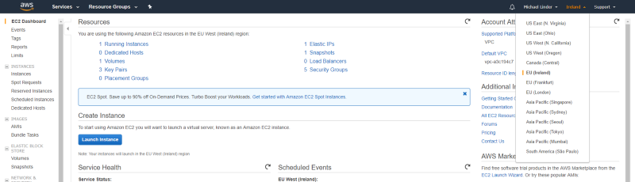

Select AWS region and launch

3. Select Ubuntu Server

https://cdn-images-1.medium.com/max/800/1*njCIH6d4m93BEb5xARdtNg.png

4. Select an instance type

In order to use the free tier contingent, it’s recommended to use t2.micro for testing purposes.

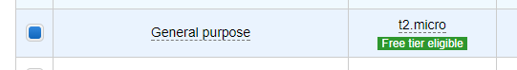

t2.micro selection

6. Configure security group

In this example following ports will be used:

Step 1: Install Mosquitto

Log into the AWS Ubuntu 16/18 machine.

$ sudo apt-get update

Install

$ sudo apt-get install mosquitto mosquitto-clients

The command above installs both the mosquitto broker and the  
publish / subscribe clients. The mosquitto broker is now installed and active. You can listen to declare any channel to subscribe and publish to test it

mosquitto_sub -h localhost -t mychanel

open the duplicate session for this Ubuntu, type the same command for publish

mosquitto_pub -h localhost -t "mychanel" -m "Hello World"

.